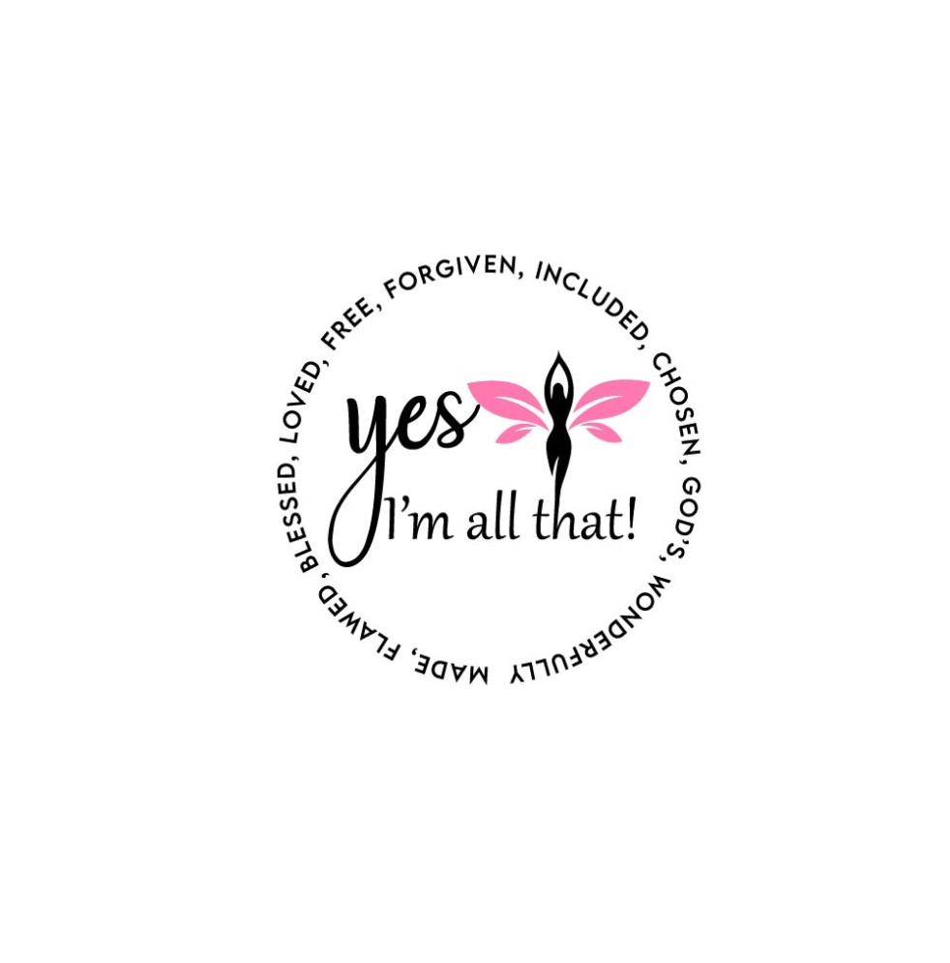

Yes, I’m All That! Foundation
Scholarship Application

About Us
Yes, I’m All That! Foundation is a 501(c) 3 non-profit founded July 14, 2020 with great hope that all women would embrace their true identity which declares them loved, forgiven, flawed but fearfully and wonderfully made. The mission of Yes, I’m All That!, INC is to help these women find their true identity, talents and gifts and push toward a more purpose driven life through education, community involvement and outreach. It is the desire of the organization to see women succeed in setting and achieving goals that will ultimately lead to an improved environment for all connected.
Yes, I’m All That! Foundation Scholarship Eligibility Requirements
- Applicants must be in pursuit of a degree at an accredited US post-secondary institution
- Applicants must provide proof of enrollment
- Applicants must provide copy of official transcript of prior or current institution
- Applicants must submit a 500 word essay that includes inspiration for completing school, future goals, and how this scholarship benefit you and those around you.
- Applicants must submit one letter of recommendation

Scholarship Reward
- Applicant will be rewarded $500
- Applicant will be honored as a scholarship recipient at the Yes, I’m All That!, INC scholarship and awards banquet

Scholarship Deadline
Applicants must submit all supporting documents and completed application by October 30, 2020 for the Spring 2021 semester.

Scholarship Submission and inquiries
Applications can be mailed or hand delivered to:
Yes, I’m All That! Foundation
Attn: Shakwanna Hadnott
11811 N. Freeway Ste #500
Houston, TX 77060

Applications and inquiries may be sent via email:

shakwannahadnott@yesimallthat.org

*Mailed applications must be postmarked by the deadline date.

Applicant Information

Name:___________________________________

Date of Birth:____________________________

Social Security Number____________________:

Address:_________________________________

Email address:_________________________________

Phone:__________________________________

High School Information

High School Name:_______________________

________________________________________

Address:_________________________________

Phone:_____________________________________ County:___________________________________

Date of Graduation:____________________________ Class Rank: _________out of ________
GPA:______________
*Please attach copy of diploma or GED

Post-Secondary School Information

Institution Name:___________________________________

Address: ________________________________

In the Spring of 2021, I will be attending college as a:
Freshmen Sophomore Junior Senior

Intended Major: _________________________________________________________________________

The Yes, I’m All That! Foundation would like to personally congratulate you for the initiative you have taken toward the pursuit of your educational endeavors. We sincerely thank you for allowing us to serve you.

